UNITED STATES
SECURITIES AND EXCHANGE COMMISSION
Washington, D.C. 20549

SCHEDULE 14A

Proxy Statement Pursuant to Section 14(a) of
the Securities Exchange Act of 1934
(Amendment No. )

Filed by the Registrant ☒
Filed by a Party other than the Registrant ☐

Check the appropriate box:
☐ | Preliminary Proxy Statement
☐ | Confidential, for Use of the Commission Only (as permitted by Rule 14a-6(e)(2))
☐ | Definitive Proxy Statement
☒ | Definitive Additional Materials
☐ | Soliciting Material under §240.14a-12

CALIBERCOS INC.
(Name of registrant as specified in its charter)

N/A
(Name of person(s) filing proxy statement, if other than the registrant)

Payment of Filing Fee (Check the appropriate box):
☒ | No fee required.
☐ | Fee paid previously with preliminary materials.
☐ | Fee computed on table in exhibit required by Item 25(b) per Exchange Act Rules 14a6(i)(1) and 0-11.

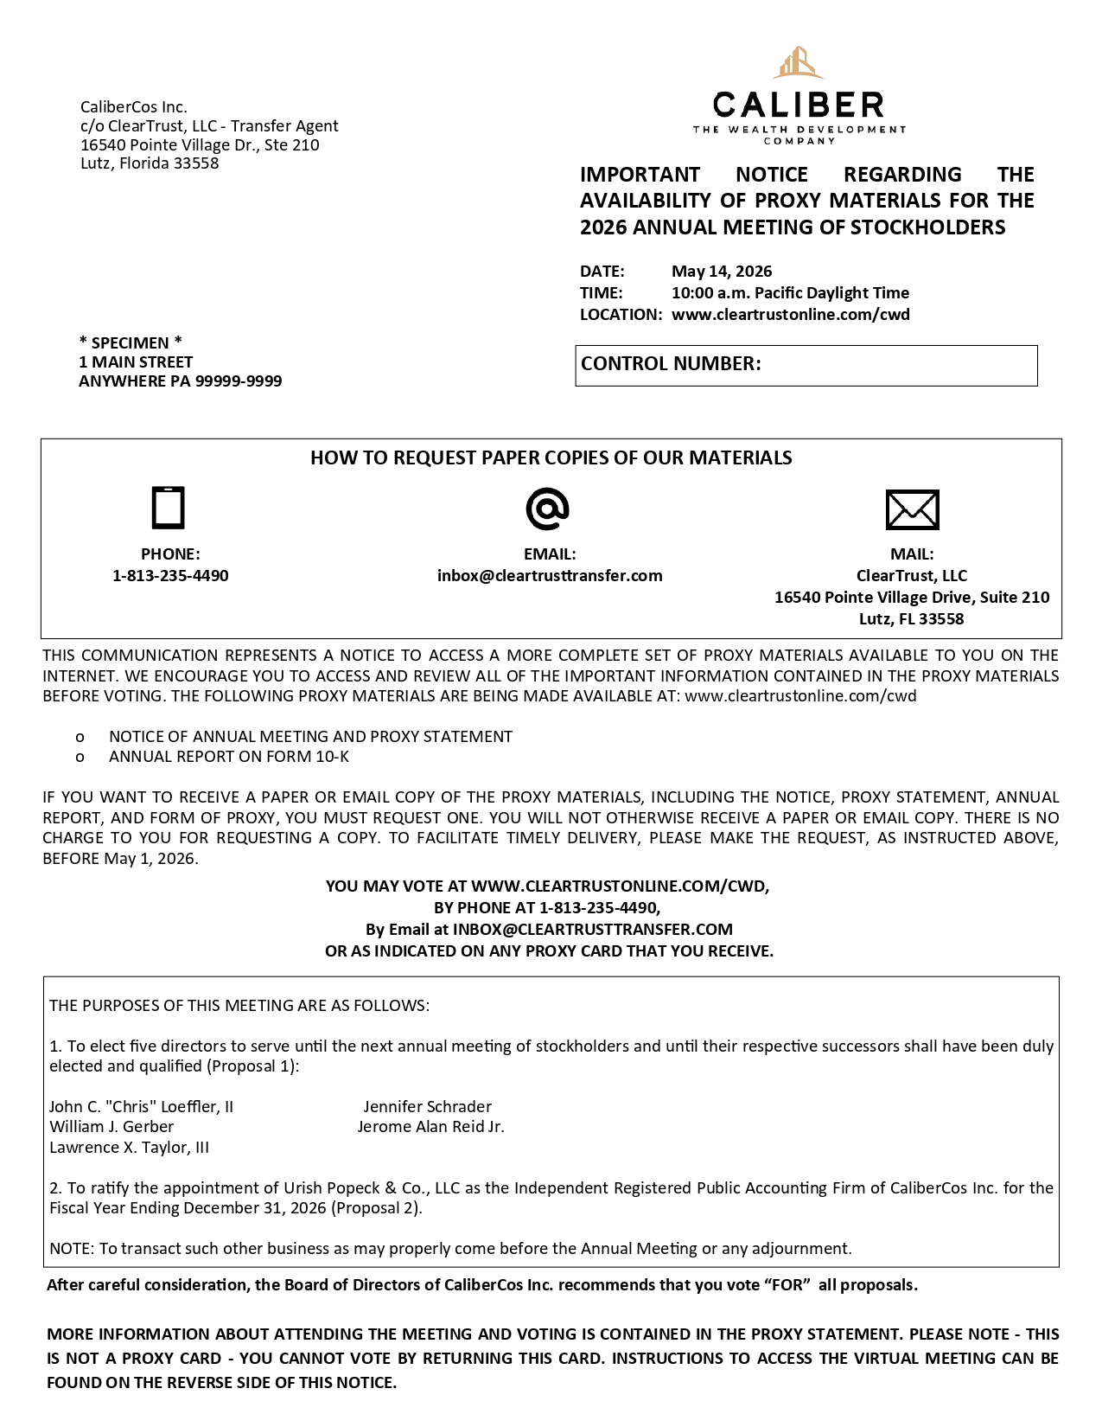
CaliberCos Inc. c/o ClearTrust, LLC - Proxy Agent 16540 Pointe Village Dr., Ste 210 Lutz, Florida 33558 YOUR VOTE IS IMPORTANT! PLEASE VOTE BY * SPECIMEN * 1 MAIN STREET ANYWHERE PA 99999 - 9999 ONLINE (FASTEST AND EASIEST): • Go to: www.cleartrustonline.com/cwd • Have your Proxy Card ready • Click "Vote Here" and enter your control number to record your vote MAIL • Mark, sign and date your Proxy Card • Fold and return your Proxy Card in the postage - paid envelope provided PHONE: • Call 1 - 813 - 235 - 4490 • Have your Proxy Card ready • Request to vote your proxy EMAIL: • Email Inbox@cleartrusttransfer.com • Provide your control number and the order you would like to vote ANNUAL MEETING OF STOCKHOLDERS CALIBERCOS INC. USE THE CONTROL NUMBER BELOW TO VOTE ONLINE AND JOIN THE VIRTUAL MEETING. DATE: TIME: May 14, 2026 10:00 AM Pacific Daylight Time LOCATION: Virtual at www.cleartrustonline.com/cwd CONTROL NUMBER: This proxy is being solicited on behalf of the Board of Directors The undersigned hereby appoints John C . Loeffler, II and Jade Leung (the "Named Proxies"), and each or any of them, as proxies for the undersigned, with full power of substitution and revocation, and authorizes each of them, to vote all the shares of Class A common stock of CaliberCos Inc . (the "Company"), which the undersigned is entitled to vote at the Annual Meeting of Stockholders of the Company and any adjournment or postponement thereof upon the matters specified and upon such other matters as may be properly brought before the meeting or any adjournment or postponement thereof . THE SHARES REPRESENTED BY THIS PROXY WILL BE VOTED AS DIRECTED OR, IF NO DIRECTION IS GIVEN, SHARES WILL BE VOTED FOR election of all director nominees under Proposal One and FOR ratification of Urish Popeck & Co . , LLC as the Company independent registered public accounting firm under Proposal Two . This proxy, when properly executed, will be voted in the manner directed herein . In their discretion, the Named Proxies are authorized to vote upon such other matters that may properly come before the meeting or any adjournment or postponement thereof . You are encouraged to specify your choice by marking the appropriate box (SEE REVERSE SIDE) but you need not mark any box if you wish to vote in accordance with the Board of Directors’ recommendation . The Named Proxies cannot vote your shares unless you sign (on the reverse side) and return this card or otherwise provide voting instructions by phone or on the internet as described above . Continued and to be signed on the reverse side

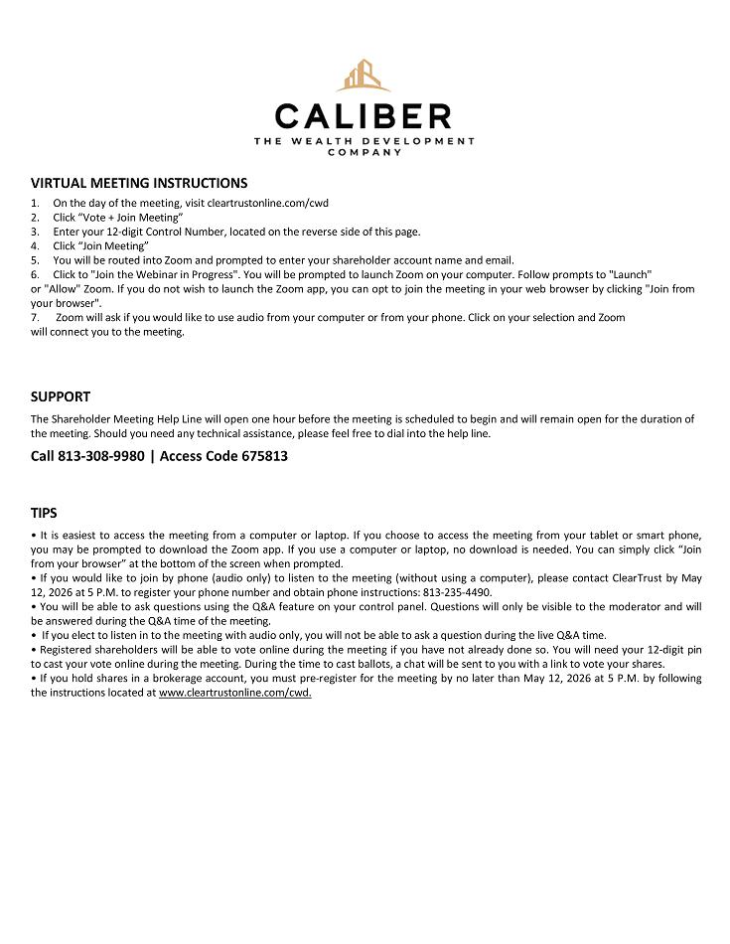
ANNUAL MEETING OF STOCKHOLDERS BOARD OF DIRECTORS RECOMMENDS YOUR VOTE PROPOSAL WITHOLD FOR FOR ALL 1. Election of Directors John C. “Chris” Loefler, II Jennifer Schrader William J. Gerber Jerome Alan Reid, Jr. Lawrence X. Taylor, III FOR AGAINST ABSTAIN FOR 2 . Ratification of the appointment of Urish Popeck & Co . , LLC as our independent registered public accounting firm for the fiscal year ending December 31 , 2026 . Authorized Signatures - Must be signed and dated for your instructions to be executed . Please sign exactly as your name(s) appears on your account . If held in joint tenancy, all persons should sign . Trustees, administrators, etc . , should include title and authority . Corporations should provide full name of corporation and title of authorized officer signing the Proxy . Signature (and Title if applicable) Signature (if held jointly) Date Date SAVE TIME & REDUCE COSTS! PLEASE CONSIDER VOTING ONLINE RATHER THAN BY MAIL. 99 LAST NAME,FIRST

